EXP NO 7: Student Attendance System
Aim:
To develop a cloud-based Student Attendance System using Zoho Creator.
Steps:
- Create a new application.
- Create a Student Attendance form.
- Add fields: Student Name, Course, Date, Present/Absent, Attendance Percentage, and OD Request.
- Create reports to display attendance records.
- Test the application by entering attendance details.
IMPLEMENTATION:
existing = Attendance[
Roll_No == input.Roll_No &&
Date == input.Date &&
Subject == input.Subject
];

if(existing.count() > 0)
{
alert "Attendance already marked for this student!";
cancel submit;
}
OUTPUT:
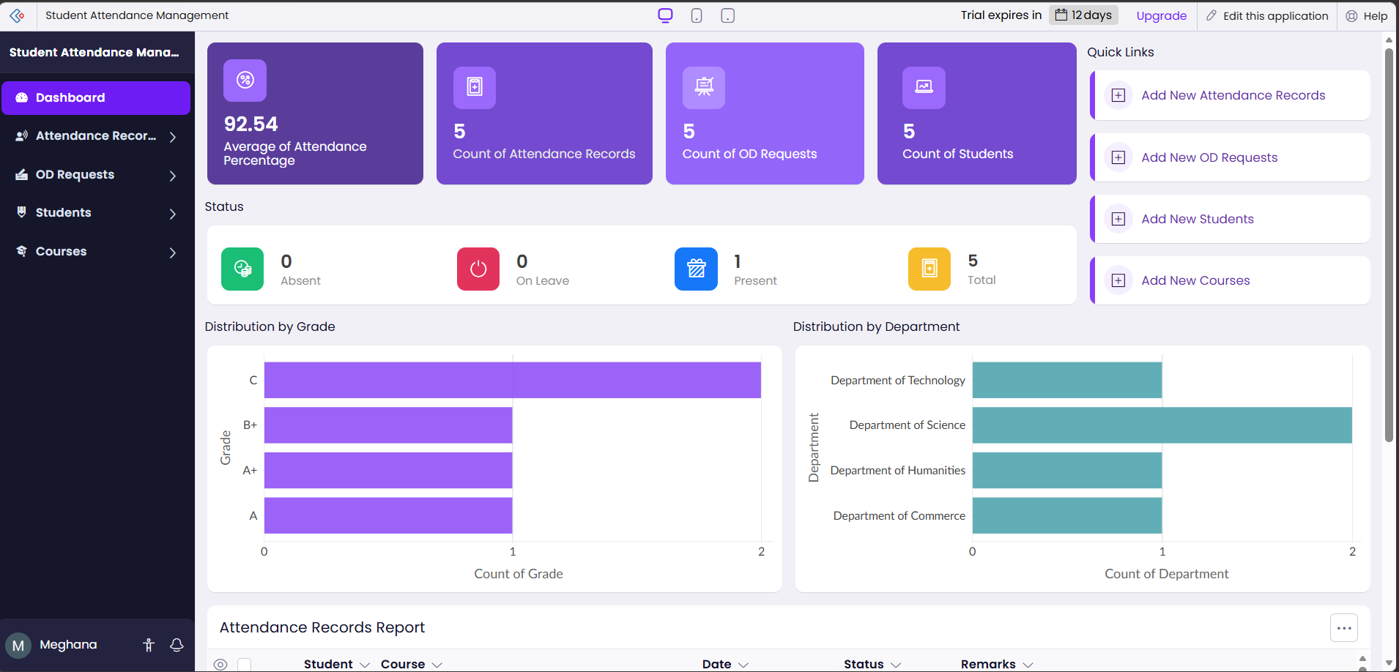
RESULT:
The cloud-based Student Attendance System using Zoho Creator was successfully implemented. The system allows teachers to record student attendance, store attendance data securely in the cloud, and generate attendance reports. It reduces manual work, improves accuracy, and provides easy access to attendance information from anywhere.

